Урок 1:
I. Вставьте глаголы в Present Simple or Present Continuous.
1. He often (go) to the cinema.
2. They (watch) TV at the moment.
3. John is outside (wash) the car.
4. Nina usually (drive) to work.
5. Father (lie) on the sofa now.
6. Claire (not/like) pizza.

II. Вставьте глаголы в Present Simple or Present Continuous

1. We (to be) always ready for our lessons.
2. My mother (to cook) very well.
3. My granny (not to work).
4. My father (not to be) at home now. He (to work) at his office.
5. What you (to do) now? I (to read) the poem.
6. Tom usually (to get up) at seven o'clock.
7. Where you (to live)?
8. Where Ann (to be)? She (to sleep).
9. Sometimes he (to watch) TV in the evening.
10. You (to understand) your teacher?

III.Выполните упражнение 3 и 9.

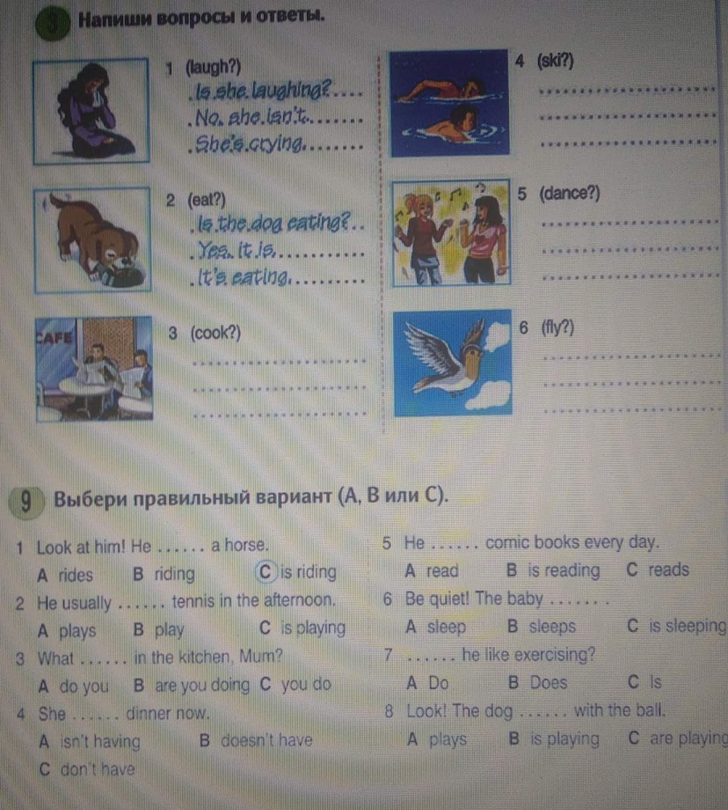

Урок 2
Подберите к глаголам из первой рамки подходящие по смыслу существительные из второй рамки.
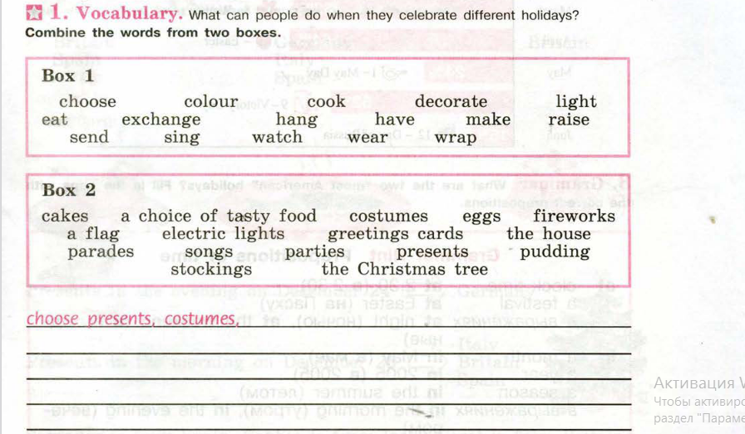

Вспомните употребление предлогов времени и выполните упражнение ниже памятки. Вставьте предлоги времени.
